Vigils for PEACE continue each Friday evening at St Marys from 9 – 11pm. Drop in to light a candle, pray and reflect.

Please continue to collect your used stamps for the Huntington’s Disease Association, greetings cards (please do not include Christmas cards) for Send Prison and goods for No 5 and Mulberry House Hostel

Thank you for bringing in your greetings cards for the ladies in Send prison - please be aware that they are not able to reuse Christmas cards which can be recycled by other means.

The prayer support GROUP contact for October is Ann Doreen 01483 535282

NEXT Sunday – 13th October

10.30am | MORNING SERVICE  David Paterson

Church Office
The church office is usually open on Monday, Wednesday and Thursday mornings. Please be aware that the office will not be open on the usual days during August.

Please send any information for the next newsletter to the office by 10.00am on Thursday morning by phone on 537655, or email to office@merrowmethodistchurch.org.uk

Our Minister George is on ‘Sabbatical’ from Oct 1st until 1st January 2025. Whilst he is away, Rev Paul Glass, 01483 575667 revpaulglass@gmail.com will have pastoral care of our congregation.

www.merrowmethodistchurch.org.uk
www.weyvalleycircuit.org.uk

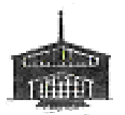
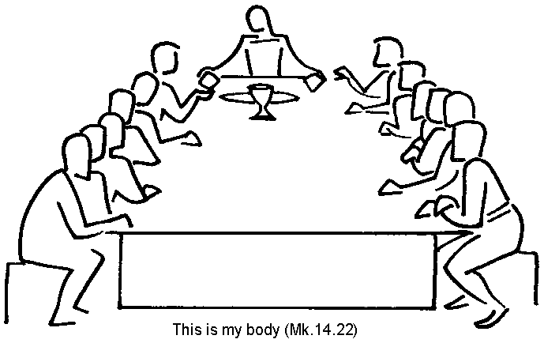

Merrow Methodist Church

6th October 2024

10.30am | Morning Service with Holy Communion  Rev Barrie Tabraham

At this time, WE PARTICULARLY ASK FOR YOUR PRAYERS FOR:
- Please pray for George and Ama during George’s sabbatical.
- Rev Sam Funnell as she recovers after an emergency operation to correct a twisted bowel
- Frank, Chris, Catherine and all the family of Cynthia Winder
- Sheila who is recovering from a broken arm
- Maureen and Eric Lupton
- All those waiting or undergoing hospital procedures and all those who have now returned home after hospital stays
- All those who are bereaved, recovering from surgery or illness
- Pray for those who suffer from addiction, that Christ will help them with the burdens they struggle with

CHURCH ACTIVITIES THIS WEEK – 7th - 12th October

Mon | WOMEN’S FELLOWSHIP - AGM, Bring and Buy, tea and cake | 2.30pm
Tues | CHURCH COUNCIL | 2.30pm
Thurs | CHARITY COFFEE MORNING in aid of the Bible Society | 10.30 –12.00
 | BADMINTON | 8.00pm

Charity COFFEE MORNING, Thursday 10th October, 10.30- 12
In aid of the Bible Society. Come and join us for coffee/tea and homemade cake and enjoy the chatter.

CIRCUIT VISION AND STRATEGY 'Talking of God Together' A 4-week discussion group for the four Fridays of October. Come and join us for a faith sharing discussion group on Zoom.
For 45 minutes from 5.15pm each Friday we welcome anyone from across the Circuit to end their week with a four-week course based on the book 'Talking of God Together'.
The course aims to build confidence in easily speaking of our faith with others. You will not need your own copy of the book, and all are welcome to join. Don't worry if you can't make all the sessions - each will be self-contained.
To join Zoom Meeting https://zoom.us/j/98448089846?pwd=enz8ldXGe4uu2SPOCosDgYO9dYVsOB.1
Meeting ID: 984 4808 9846 Passcode: 655618

COFFEE CORNER, STOUGHTON METHODIST CHURCH Fortnightly on Tuesday from 10am – 12noon. 15th, 29th October, 12th and 26th November, 10th and 17th December. 17th December will be in aid of Cherry Trees. Enjoy coffee and a chat, and a game or book.

A celebration of women of the Bible exhibition at St Mary’s, Guildford, 28th October to 17th November
A series of seven paintings (in the style of icons, though not strictly icons) by Bulgarian Orthodox artist Silvia Dimitrova depicting Women of the Bible - Sarah, Miriam, Ruth - Esther, Mary Magdalene, Lydia, Priscilla - with the reflective poems by Graham Kings. The paintings have been exhibited in a number of places, including Chester Cathedral, Canterbury Cathedral (during the Lambeth Conference) and Rochester Cathedral.
Extraordinary Women of the Bible, Friday 15th November, at 7.00pm, at St Mary’s Guildord. Seven anthems performed by In Nomine Choir to complement the paintings and poems. Tickets £10. See poster.

