Vigils for PEACE continue each Friday evening at St Marys from 9 – 11pm. Drop in to light a candle, pray and reflect.

Please continue to collect your used stamps for the Huntington’s Disease Association, greetings cards (please do not include Christmas cards) for Send Prison and goods for No 5 and Mulberry House Hostel

Thank you for bringing in your greetings cards for the ladies in Send prison - please be aware that they are not able to reuse Christmas cards which can be recycled by other means.

The prayer support GROUP contact for September is Doreen 01483 578214

NEXT Sunday – 6th October

10.30am | Rev Barrie Tabraham with HC

Church Office
The church office is usually open on Monday, Wednesday and Thursday mornings. Please be aware that the office will not be open on the usual days during August.

Please send any information for the next newsletter to the office by 10.00am on Thursday morning by phone on 537655, or email to office@merrowmethodistchurch.org.uk

Our Minister George is on ‘Sabbatical’ from Oct 1st until 1st January 2025. Whilst he is away, Rev Paul Glass , 01483 575667 revpaulglass@gmail.com will have pastoral care of our congregation.

www.merrowmethodistchurch.org.uk
www.weyvalleycircuit.org.uk




Merrow Methodist Church
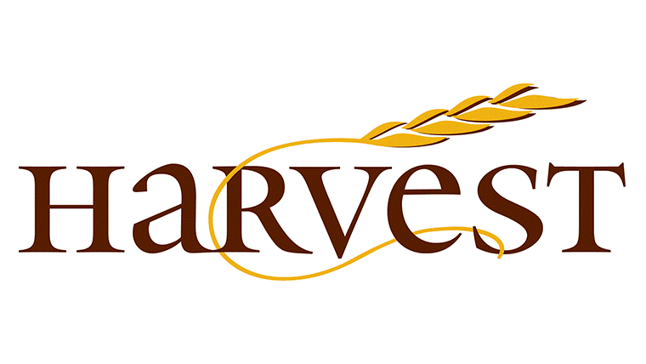
29th September 2024

10.30am | HARVEST FESTIVAL  Rev George Quarm  Please stay for lunch - this will be a taste of food from around the world!

At this time, WE PARTICULARLY ASK FOR YOUR PRAYERS FOR:
- Please pray for George and Ama during George’s sabbatical.
- Rev Sam Funnell as she recovers after an emergency operation to correct a twisted bowel
- Frank, Chris, Catherine and all the family of Cynthia Winder
- Sheila who is recovering from a broken arm
- Maureen and Eric Lupton
- All those waiting or undergoing hospital procedures and all those who have now returned home after hospital stays
- All those who are bereaved, recovering from surgery or illness
- Remember in your prayers today all victims of violence and abuse, that we can seek justice and peace for them.

CHURCH ACTIVITIES THIS WEEK – 29th September - 5th October

Tues | Lunch Club followed by AGM | 12 – 1.30pm
 | Morning Bible Study – see Pauline Daniels for details | 10am
Wed | CHOIR PRACTICE | 10.30am
Thurs | THURSDAY COFFEE MORNING | 10.30 –11.45am
 | BADMINTON | 8.00pm

Sam Funnel would like to send a message of thanks to everyone in the circuit for all the love, support and prayers she has received during the past few weeks. She is sorry she’s unable to thank everyone individually, but she is no less grateful. She is now at home and starting on her journey of recovery.

THANK YOU to all those who attended the Women’s Fellowship coffee morning. £217 was raised for Mission Aviation Fellowship.

Thank You card
A thank you card from Sally White and Alison Allman (John Allman’s daughters) has been received and has been put on the notice board for all to read.

THURSDAY Coffee MorningS, 10.30 - 11.45am Do drop in for a drink and a chat with others from the church and local community

Charity COFFEE MORNING, Thursday 10th October, 10.30- 12
In aid of the Bible Society. Come and join us for coffee/tea and homemade cake and enjoy the chatter.

VINTAGE TEA PARTIES, SUNDAY 6th OCTOBER

Afternoon tea and live entertainment at two locations:

West Horsley Village Hall, The Street, West Horsley, 3.00pm - 5.00pm Arranged by Home Counties Carers, East Horsley WI and West Horsley WI

and at St Mary’s Church, Church Rooms, Send Road, Send,
2.30pm – 4.30pm. Arranged by Home Counties Carers and The Coffee Shop.
RSVP to Ingrid at Home Counties Carers to reserve your place. Transport can be arranged if necessary.
Phone 01483 224985/ 07591 597403
Email: iclift@homecountiescarers.co.uk

