Vigils for PEACE continue each Friday evening at St Marys from 9 – 11pm. Drop in to light a candle, pray and reflect.

The prayer support GROUP contact is Helen Belsham 01483 823742
Please continue to collect your used stamps for the Huntington’s Disease Association, greetings cards (please do not include Christmas cards) for Send Prison and goods for No 5 and Mulberry House Hostel
Thank you for bringing in your greetings cards for the ladies in Send prison - please be aware that they are not able to reuse Christmas cards which can be recycled by other means.

NEXT Sunday – 8th September

10.30am | MORNING SERVICE  Rev Peter Hills
6.30pm | EVENING SERVICE with HOLY COMMUNION  Rev George Quarm

Church Office
The church office is usually open on Monday, Wednesday and Thursday mornings. Please be aware that the office will not be open on the usual days during August.

Please send any information for the next newsletter to the office by 10.00am on Thursday morning by phone on 537655, or email to office@merrowmethodistchurch.org.uk

Our Minister George’s contact details are :
Email unclegeorge.quarm@gmail.com
Mobile Phone – 07852557067, Landline - 01483-575432

www.merrowmethodistchurch.org.uk
www.weyvalleycircuit.org.uk

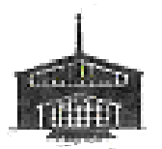

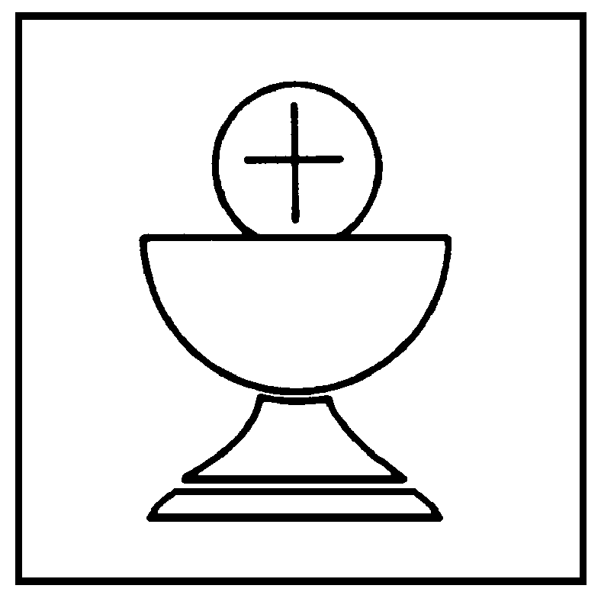

Merrow Methodist Church

1st September 2024

10.30am | MORNING SERVICE with HOLY COMMUNION  Rev George Quarm

Welcome Service for Rev Shaun Sanders at 3pm this afternoon at Walton-on-Thames
Afternoon tea will be served following the service.

At this time, WE PARTICULARLY ASK FOR YOUR PRAYERS FOR:
- Rev Sam Funnell after an emergency operation on Thursday evening to correct a twisted bowel
- Val Carter and Michelle following Dave’s death
- Joan Tabraham and family on the recent death of her sister
- Frank, Chris, Catherine and all the family of Cynthia Winder
- Sheila who is recovering from a broken arm
- Maureen and Eric Lupton
- All those waiting or undergoing hospital procedures and all those who have now returned home after hospital stays
- All those who are bereaved, recovering from surgery or illness
- All those people from our community who come to our premises to celebrate special occasions, such as birthdays.

CHURCH ACTIVITIES THIS WEEK – 2nd – 7th September

Mon | Women’s Fellowship – Gaby North, Leprosy Charity. See below. | 2.30pm
Tues | LUNCH CLUB | 12.30-1.30pm
Wed | CHOIR PRACTICE | 10.30am
Thurs | THURSDAY COFFEE MORNING | 10.30 –12.00

WOMEN’S FELLOWSHIP, Monday 2nd September. Gaby North is the Community Partnership’s Manager for Leprosy Mission. People with leprosy are ignored and excluded by society, people living in the shadows desperate for care and desperate to belong. All are welcome to come and support Gabby. We always have tea and biscuits afterwards! Suzanne

THURSDAY Coffee MorningS, 10.30 - 11.45am Do drop in for a drink and a chat with others from the church and local community

Saturday 7th September, 2.30pm to 4.30pm - You are invited to a Cream Tea at Godalming United Church, Bridge Road, Godalming, in Church Gardens or River Room (depending on the weather!). Donations in aid of the Gambian Ophthalmic Project which provides funds for cataract operations and follow-up care.

QUIZ, Friday 4 October, 7pm – 10.30pm, at Christ Church Guildford, Waterden Road. Teams of 6-8 people, so get your friends to make up a team, or come on your own & we will allocate you to a team. Tickets £15 per head to include delicious 2 course Asian inspired supper. Bring your own drinks! Parking is limited parking on site, nearest car parks at G Live & London Road station. Enquiries 07500 834658. To book
https://ccg.churchsuite.com/events/ucburwfw

The Monthly Circuit Prayer Diary is attached. It is available on the Wey Valley Circuit website as a PDF document. Prayers are also shown by date on the Calendar, and each day the prayer for that day will be on the Home Page under Coming Events

Walking Sticks and Crutches for Gaza
The Anglo-Jordanian Society is collecting unwanted walking sticks and crutches, which the NHS is reluctant to take back, and sending them to Gaza for the many amputees that need them there. Royal Jordanian Airways will transport them free of charge.
If you have either walking sticks or crutches that you are able to donate, you can either bring them to the church before September 17th or take them directly to Burpham Village Hall on September 3rd and 17th between 12.30 and 4pm. Your help and support are very much appreciated.

To

I really h

